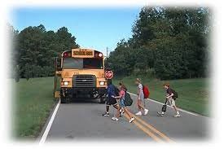

OPERATION SAFE STOP
Certificate of Appreciation

is hereby granted to:

THANK YOU FOR PARTICIPATING IN
NEW HAMPSHIRE'S 2019 OPERATION SAFE STOP AND HELPING TO KEEP OUR SCHOOL BUS RIDERS SAFE.

Regional/Local Coordinator Date

